Software Design Document (SDD)
Module: UART Driver
Version | 1.0
Authors | David Mijares, Ximena Cedillo, Xavier Clemente
Files | UART.h / UART.c / serial.h / serial.c
Target MCU | STM32F411RE (Cortex-M4)
Course | Microcontrollers and Embedded Systems — CETYS Universidad

1. Introduction

1.1. Purpose
This document describes the software design and architecture of the UART driver module developed for the STM32F411RE microcontroller, as part of the Microcontrollers and Embedded Systems course at CETYS Universidad. The design is based on the code in UART.h, UART.c, serial.h, and serial.c, and provides details on data structures, register-level algorithms, and control flow to guide implementation and testing.
This SDD serves as a reference for maintenance, testing, and future improvements of the USART2 communication firmware.

1.2. Scope
The UART driver is a low-level software component for embedded systems. It abstracts USART2 hardware registers and provides a clean C API for higher-level modules to perform serial communication without direct register access. The system performs the following operations:
- Initializes the USART2 peripheral with a fixed 115200 baud rate using a 16 MHz system clock.
- Enables and manages the USART2 peripheral clock via the RCC APB1ENR register.
- Configures PA2 (TX) and PA3 (RX) GPIO pins to Alternate Function 7 mode via the GPIO driver.
- Computes the BRR register value using rounded integer arithmetic: (clk + baud/2) / baud.
- Transmits single bytes via the DR register, polling the TXE flag in SR.
- Provides a high-level serial_printf() function supporting %s, %d, %u, %x, %c, and %% format specifiers.
- Does not depend on HAL libraries — all hardware interaction uses direct MCU register access.

1.3. Definitions and Acronyms
Term | Definition
UART/USART | Universal (Synchronous/) Asynchronous Receiver-Transmitter — serial protocol
USART2 | STM32 USART peripheral on APB1 bus — used exclusively by this driver
DR | Data Register — write to transmit, read to receive (shared register in F4)
SR | Status Register — holds TXE, RXNE, TC, and error flags
TXE | Transmit Data Register Empty flag — set when DR is ready for new data
RXNE | Read Data Register Not Empty flag — set when received data is available
BRR | Baud Rate Register — integer divisor for baud generation; formula: (clk+baud/2)/baud
CR1 | Control Register 1 — bits: UE(13), TE(3), RE(2)
APB1ENR | APB1 Enable Register — bit 17 enables USART2 clock
RCC | Reset and Clock Control — manages peripheral clocks
AF7 | Alternate Function 7 — GPIO mapping for USART2 TX/RX on PA2/PA3
VA_LIST | C variadic argument list type used by serial_printf() for format parsing
GPIO | General Purpose Input/Output — PA2 and PA3 configured as AF7
HAL | Hardware Abstraction Layer — NOT used; driver uses direct register access
CMSIS | Cortex Microcontroller Software Interface Standard — provides USART_TypeDef
FR-x | Functional Requirement x as defined in this document

1.4. Requirements
All functional requirements implemented in UART.h / UART.c / serial.h / serial.c are listed below.
Req. ID | Type | Description
FR-1 | Functional | baud_rate() shall compute the USART BRR register value using rounded integer division: (clk + baud/2U) / baud.
FR-2 | Functional | uart_init() shall enable the USART2 peripheral clock via RCC->APB1ENR, write BRR, and set UE | TE | RE in CR1.
FR-3 | Functional | uart_write() shall poll SR.TXE until set, then write one byte to DR for transmission.
FR-4 | Functional | serial_init() shall call gpio_initPort(), gpio_setAlternateFunction() for TX and RX pins (AF7), then call uart_init().
FR-5 | Functional | serial_printf() shall format a string using utils_snprintf() and transmit each character via uart_write() until NUL.

2. System Architecture

2.1. High-Level Design
The UART driver follows a layered firmware architecture separating application logic from hardware access:
- Application Layer: Calls serial_printf() or uart_write() to send data. Never accesses USART2 registers directly.
- Serial Module Layer (serial.c / serial.h): Provides high-level interface. Calls uart_init() during initialization, and uart_write() per character inside serial_printf().
- UART Driver Layer (UART.c / UART.h): Configures USART2 hardware. Only layer that writes to APB1ENR, BRR, CR1, and DR. Depends on GPIO driver for pin configuration.
- GPIO Driver Layer (GPIO.c / GPIO.h): Configures PA2/PA3 alternate function registers. Used only during serial_init().
- Hardware Layer: STM32F411RE USART2 peripheral registers accessed through CMSIS USART_TypeDef. Not directly accessible from layers above the UART driver.

2.2. Module Interfaces
- Public API (UART.h): baud_rate(), uart_init(), uart_write(). All return void except baud_rate() which returns uint32_t.
- Public API (serial.h): serial_init(), serial_printf(). Both return void.
- Internal Macros: SYSTEM_CLOCK = 16000000, STANDARD_BRR = 115200 (defined in UART.h).
- Dependencies: stm32f4xx.h (CMSIS USART_TypeDef, RCC_TypeDef), GPIO.h (gpio_initPort, gpio_setAlternateFunction), utils.h (utils_snprintf), stdarg.h (va_list). No HAL or LL library.

3. Detailed Design

3.1. Class Diagram
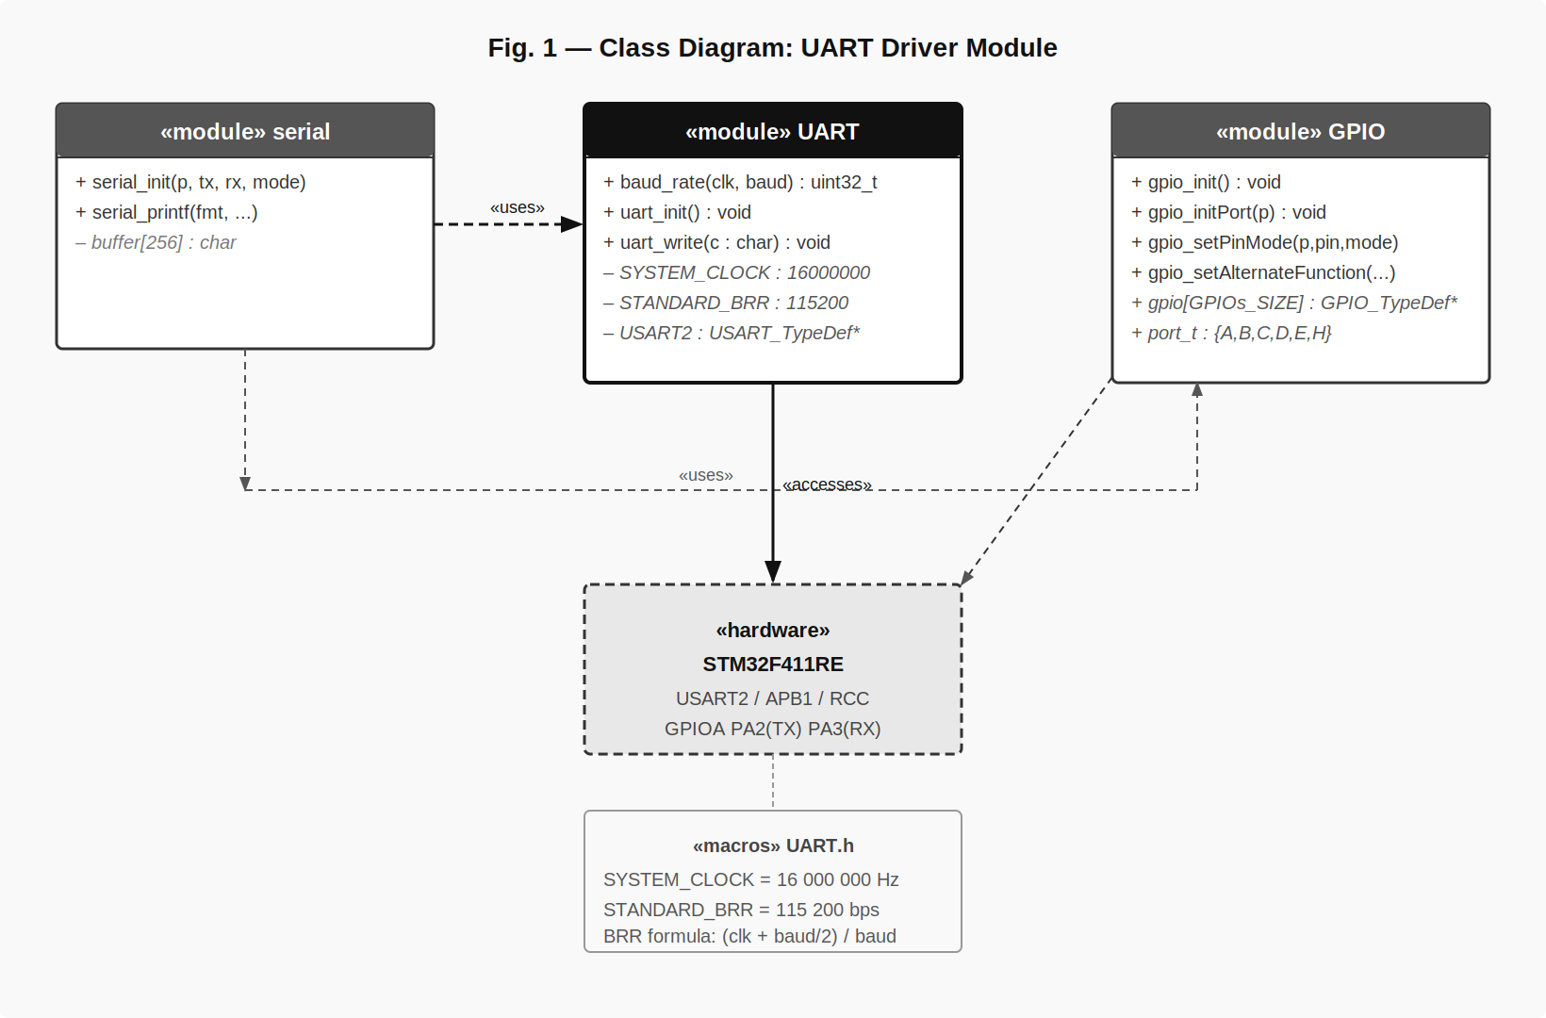
Fig. 1 — Class Diagram: UART Driver Module
Fig. 1 shows the three modules (serial, UART, GPIO) and their relationships. The serial module depends on both UART and GPIO during initialization, and on UART alone during transmission. The UART module directly accesses the STM32F411RE hardware registers. The two macros SYSTEM_CLOCK and STANDARD_BRR are defined in UART.h and consumed by uart_init().

3.2. Module Behavior — Sequence Diagrams and State Machine
The following diagrams illustrate the complete behavior of the driver before the per-function details in Section 3.3.

baud_rate() — FR-1
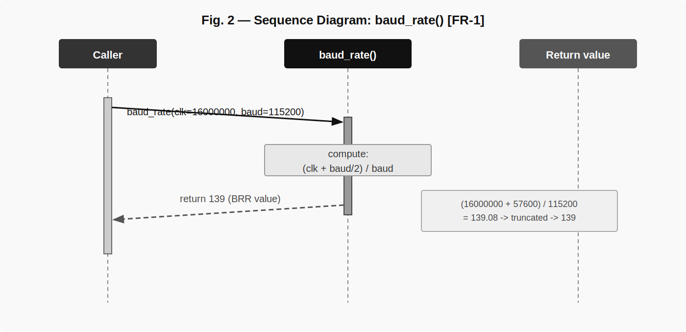
Fig. 2 — Sequence Diagram: baud_rate() [FR-1]
Fig. 2 shows that baud_rate() takes clk and baud as inputs, computes (clk + baud/2U) / baud in integer arithmetic, and returns the BRR value. For the default configuration (16 MHz / 115200) the result is 139, which rounds correctly to the nearest integer.

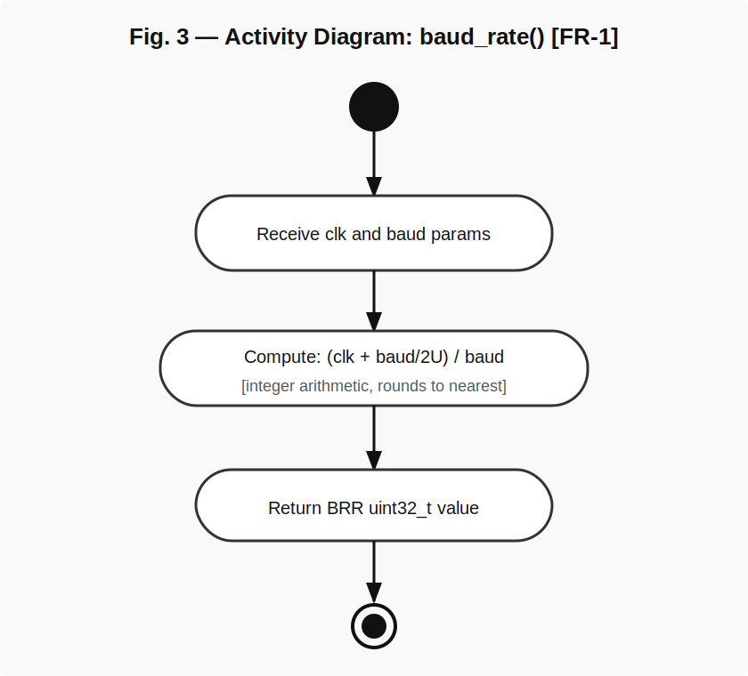
Fig. 3 — Activity Diagram: baud_rate() [FR-1]
Fig. 3 confirms a purely linear flow with no decision nodes. The function receives the two parameters, performs a single arithmetic expression, and returns a uint32_t.

uart_init() — FR-2
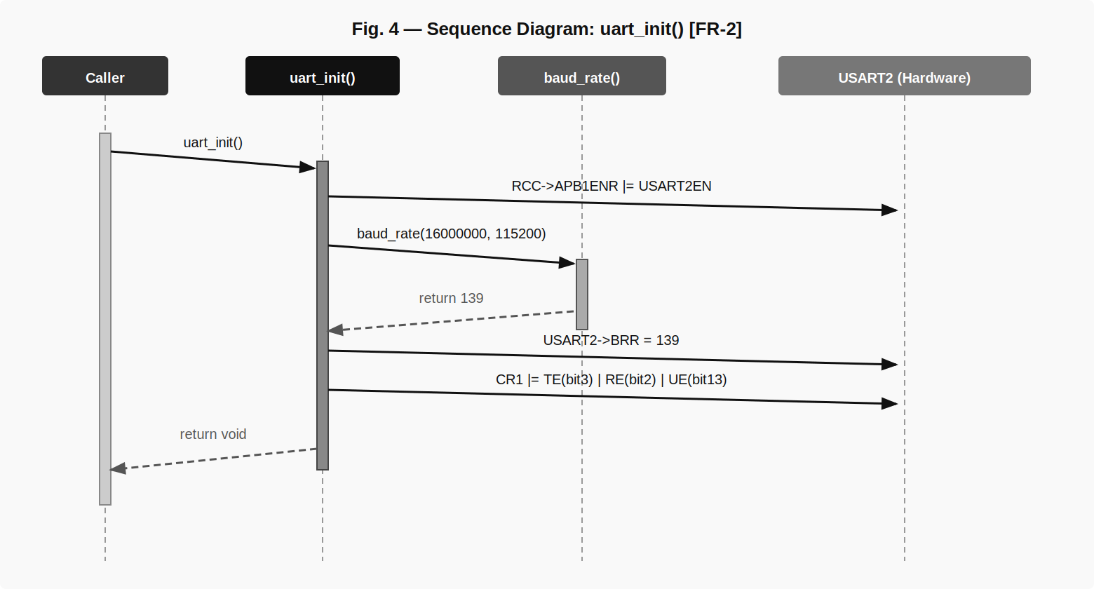
Fig. 4 — Sequence Diagram: uart_init() [FR-2]
Fig. 4 shows the three hardware write operations performed by uart_init(): enabling the USART2 clock in RCC->APB1ENR, writing BRR with the value returned by baud_rate(), and enabling the transmitter, receiver, and USART peripheral via CR1.

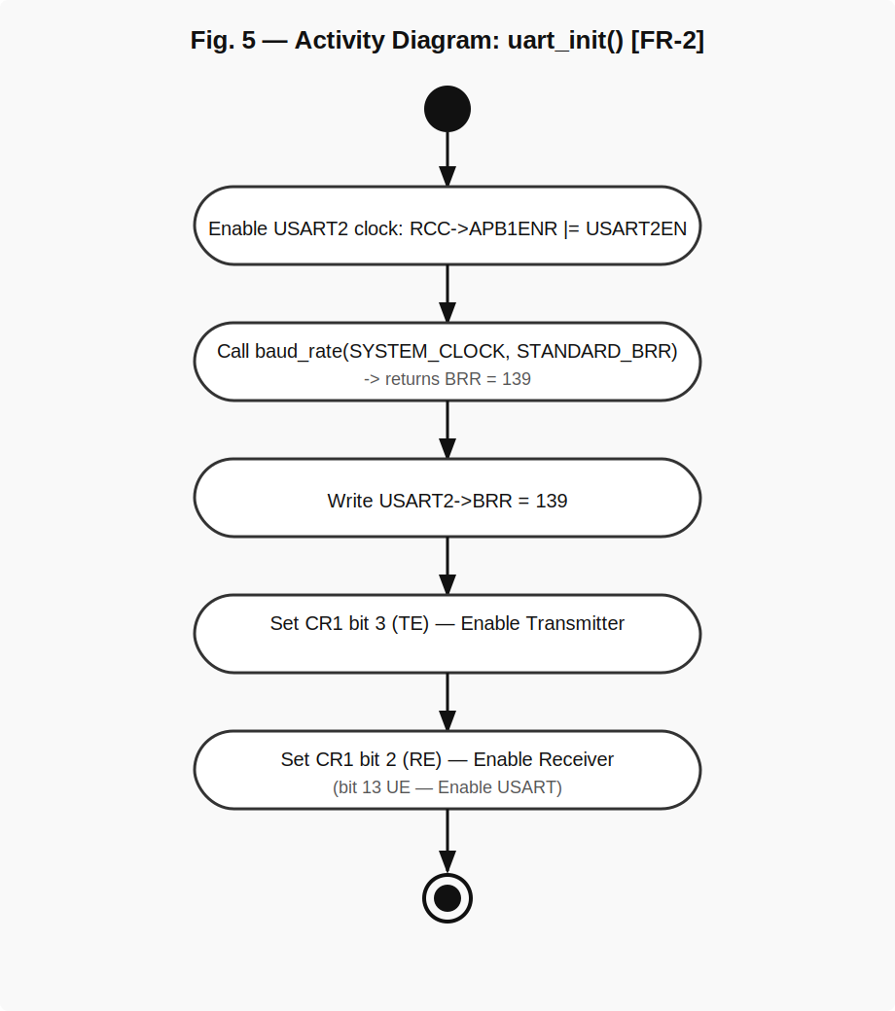
Fig. 5 — Activity Diagram: uart_init() [FR-2]
Fig. 5 shows the five sequential steps of uart_init(): clock enable, baud_rate() call, BRR write, TE set (bit 3), RE set (bit 2), and UE set (bit 13). There are no conditional branches — the function always succeeds when called after gpio configuration.

uart_write() — FR-3
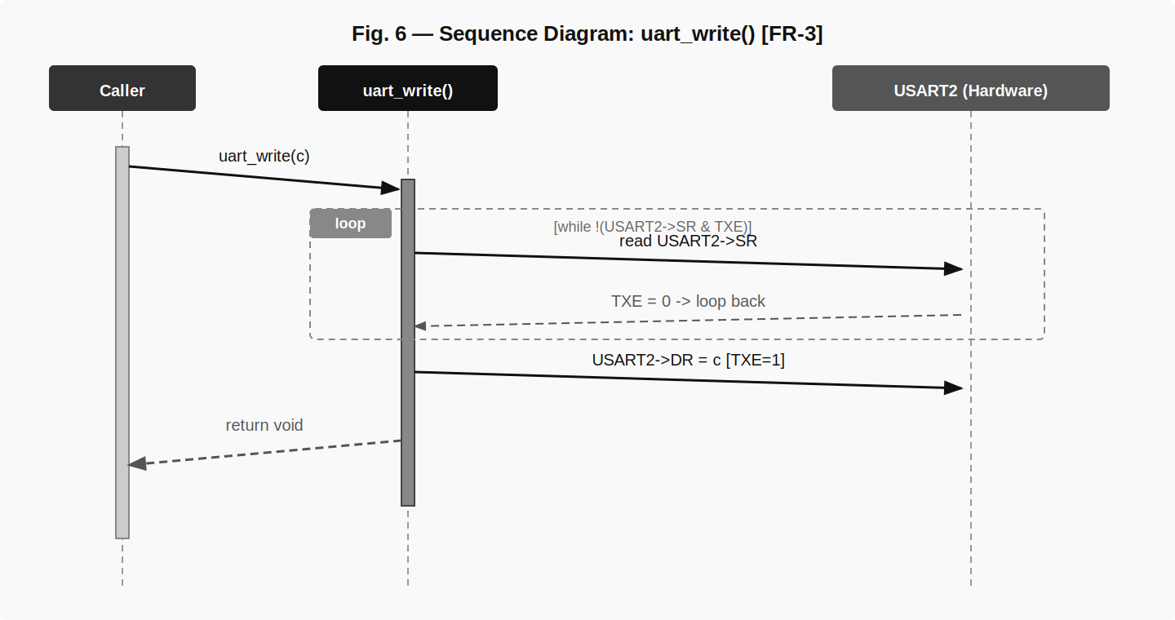
Fig. 6 — Sequence Diagram: uart_write() [FR-3]
Fig. 6 shows the polling loop over the TXE flag. The function reads SR repeatedly until TXE is set, then writes the byte to DR. The hardware automatically clears TXE when DR is loaded and begins shifting the byte out on the TX line.

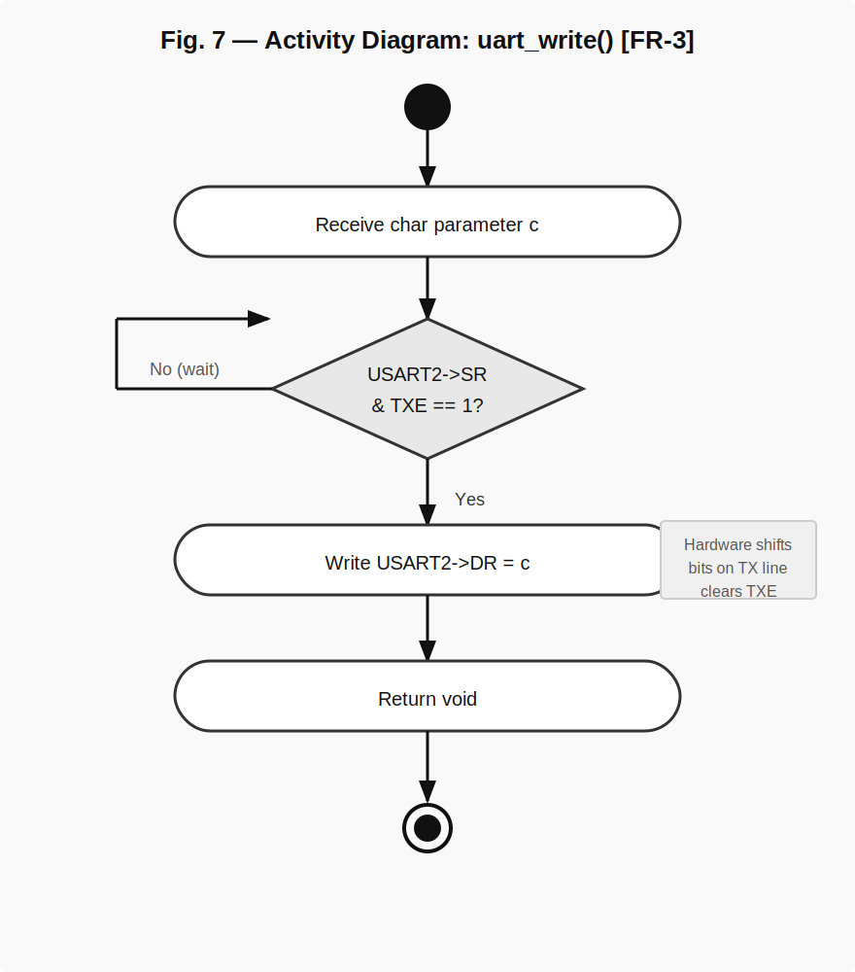
Fig. 7 — Activity Diagram: uart_write() [FR-3]
Fig. 7 highlights the decision diamond that drives the polling loop. The No branch loops back to re-read SR. The Yes branch proceeds to a single DR write and returns.

serial_init() — FR-4
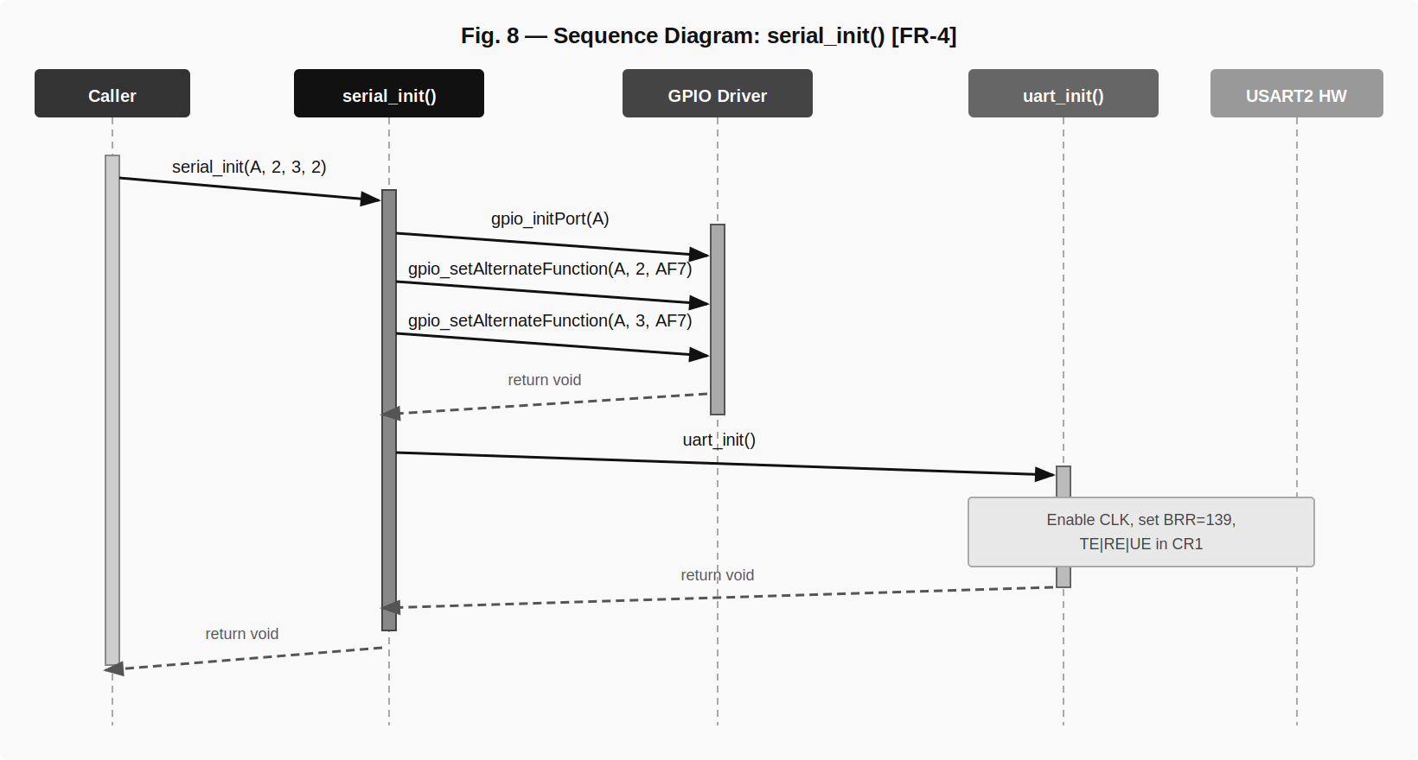
Fig. 8 — Sequence Diagram: serial_init() [FR-4]
Fig. 8 shows the complete initialization chain: gpio_initPort() enables the AHB1 clock for GPIOA, two calls to gpio_setAlternateFunction() configure PA2 to AF7 (USART2_TX) and PA3 to AF7 (USART2_RX), then uart_init() is called to bring up USART2.

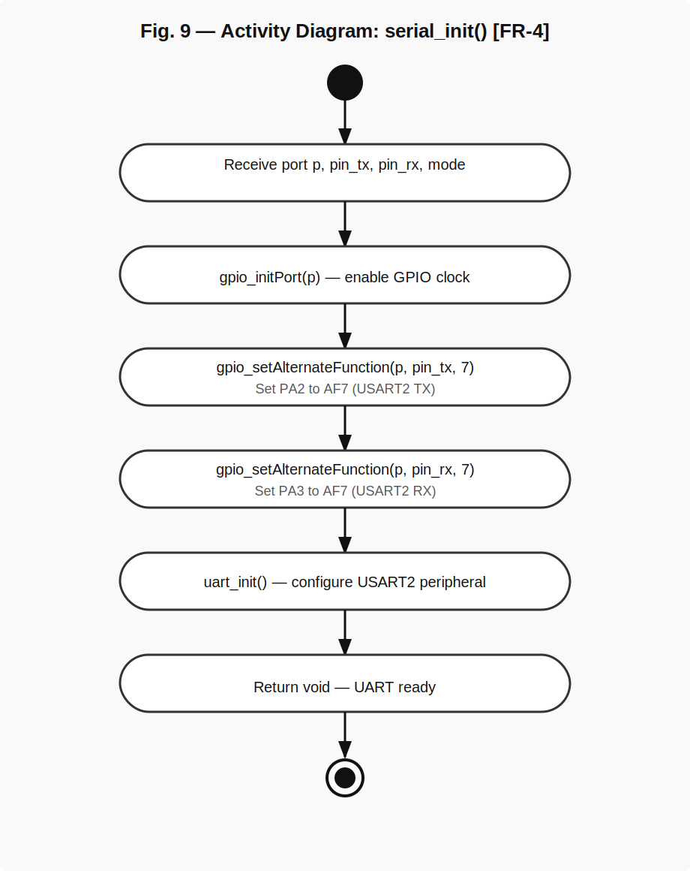
Fig. 9 — Activity Diagram: serial_init() [FR-4]
Fig. 9 shows the five sequential steps of serial_init() with no conditional branches. All parameters received are passed directly to their corresponding lower-layer calls.

serial_printf() — FR-5
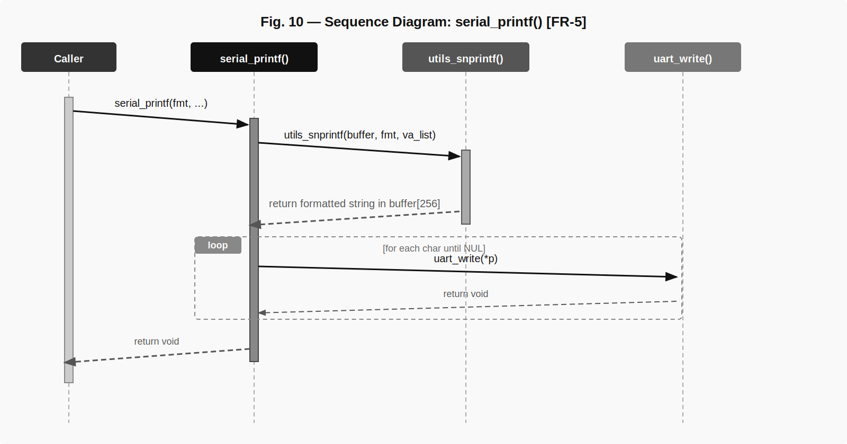
Fig. 10 — Sequence Diagram: serial_printf() [FR-5]
Fig. 10 shows the two-phase operation of serial_printf(): first utils_snprintf() formats the entire string into a 256-byte stack buffer using the variadic argument list; then a loop calls uart_write() for each character in the buffer until the NUL terminator is reached.

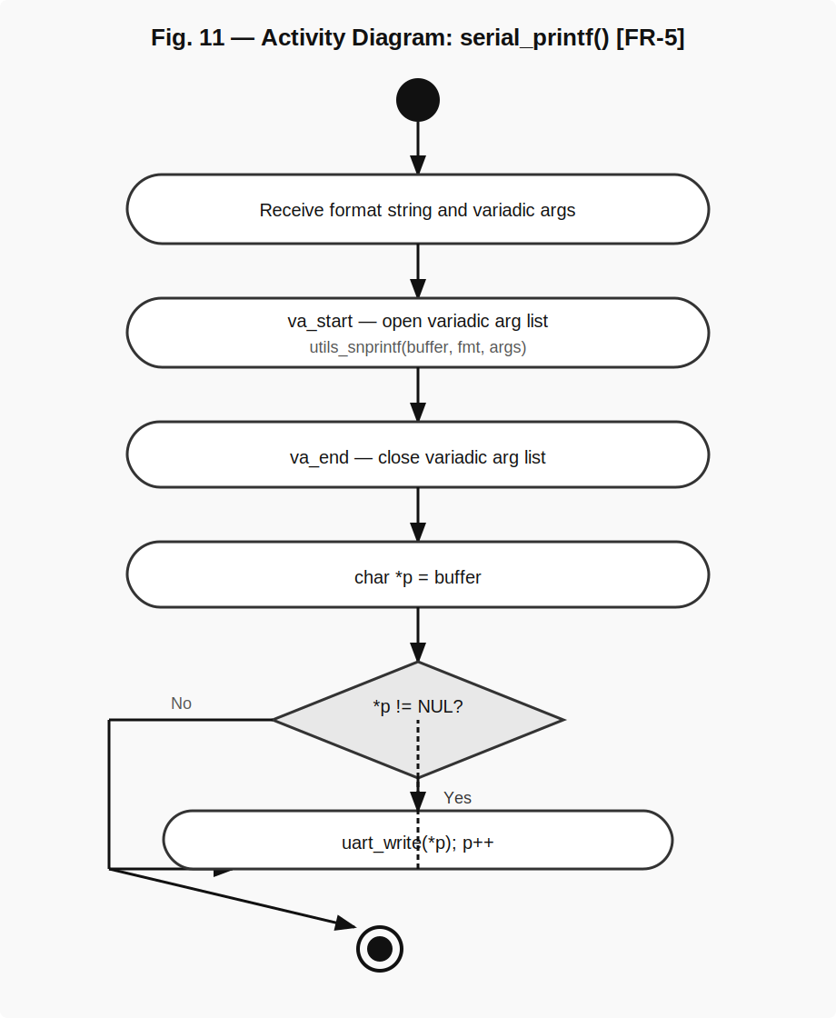
Fig. 11 — Activity Diagram: serial_printf() [FR-5]
Fig. 11 shows the va_start/va_end lifecycle bracketing the snprintf call, the char pointer initialization, the decision diamond that drives the transmission loop, and the termination condition at the NUL character.

State Diagram — UART Driver System

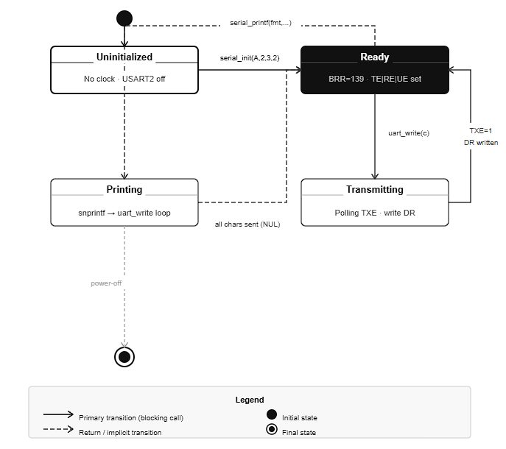
Fig. 12 — State Diagram: UART Driver System
Fig. 12 shows the four runtime states of the UART system: UNINITIALIZED (USART2 off, no clock), READY (clock enabled, BRR set, TE/RE/UE active), TRANSMITTING (polling TXE, DR write pending), and PRINTING (iterating through a buffer character by character via serial_printf()). The driver returns to READY after each transmitted character.

3.3. UART Driver Internals
Baud Rate Calculation: baud_rate() uses the formula (clk + baud/2U) / baud with unsigned integer arithmetic. Adding half the denominator before dividing implements round-to-nearest, avoiding the truncation error of plain integer division. For SYSTEM_CLOCK=16000000 and STANDARD_BRR=115200: (16000000 + 57600) / 115200 = 16057600 / 115200 = 139.37 → 139. This matches the USART2 BRR value for 115200 baud at 16 MHz.

Initialization Sequence: uart_init() enables the USART2 clock by ORing bit 17 into RCC->APB1ENR, then writes BRR, then separately sets TE (bit 3), RE (bit 2), and UE (bit 13) in CR1. Setting UE last is correct practice — the peripheral must be fully configured before being enabled.

Transmit Polling: uart_write() spins on the TXE flag in USART2->SR. Once TXE=1, writing USART2->DR loads the shift register and hardware clears TXE. There is no timeout — the function blocks indefinitely. This is safe in single-threaded polling designs but must not be called before uart_init().

GPIO Pin Configuration: serial_init() calls gpio_initPort(A) to enable GPIOA clock via RCC->AHB1ENR, then calls gpio_setAlternateFunction(A, 2, 7) and gpio_setAlternateFunction(A, 3, 7) to assign AF7 to PA2 (USART2_TX) and PA3 (USART2_RX). AF7 is the correct mapping for USART2 on the STM32F411RE.

String Formatting: serial_printf() opens a va_list, passes it to utils_snprintf() which fills a 256-byte stack buffer, closes the va_list, then iterates through the buffer with a char pointer sending each byte via uart_write(). Strings longer than 255 characters are silently truncated.

4. Application Programming Interfaces

4.1. Data Types and Macros
SYSTEM_CLOCK: Macro defined in UART.h. Value = 16000000 (16 MHz). Represents the HSI oscillator frequency used by USART2 before PLL configuration.

STANDARD_BRR: Macro defined in UART.h. Value = 115200. The standard baud rate used for all UART communications in this driver.

Note: port_t enumeration is defined in GPIO.h and reused by serial_init().

4.2. Register Map
Register | Offset / Address | Access | Used By / Purpose
RCC->APB1ENR | 0x40023840 | R/W | uart_init() — bit 17 enables USART2 clock
USART2->BRR | +0x08 | R/W | uart_init() — integer baud rate divisor (value: 139)
USART2->CR1 | +0x0C | R/W | uart_init() — UE(bit13), TE(bit3), RE(bit2)
USART2->SR | +0x00 | R/W | uart_write() — TXE flag polling
USART2->DR | +0x04 | R/W | uart_write() — write byte to transmit
GPIOA->MODER | +0x00 | R/W | gpio_setAlternateFunction() — PA2/PA3 to AF mode (0b10)
GPIOA->AFR[0] | +0x20 | R/W | gpio_setAlternateFunction() — PA2/PA3 AF7 assignment

4.3. Function Definitions

baud_rate
Function Name | baud_rate
Syntax | uint32_t baud_rate(uint32_t clk, uint32_t baud)
Parameters (in) | clk | uint32_t — System clock frequency in Hz. Typically SYSTEM_CLOCK (16000000).
Parameters (in) | baud | uint32_t — Desired baud rate. Typically STANDARD_BRR (115200).
Parameters (inout) | N/A
Parameters (out) | N/A
Return value | uint32_t | Computed BRR value to write to USART2->BRR. For 16 MHz / 115200 returns 139.
Description | Computes the USART baud rate register value (FR-1) using rounded integer arithmetic: (clk + baud/2U) / baud. Adding half the denominator corrects for integer truncation error.
Constraints | No input validation — caller must ensure baud > 0 to avoid division by zero. Result is truncated uint32_t; non-standard baud rates may introduce small error.
Available via | UART.h

uart_init
Function Name | uart_init
Syntax | void uart_init(void)
Parameters (in) | N/A
Parameters (inout) | N/A
Parameters (out) | N/A
Return value | void | Always succeeds. No error reporting.
Description | Initializes USART2 (FR-2). Enables USART2 clock via RCC->APB1ENR bit 17. Calls baud_rate(SYSTEM_CLOCK, STANDARD_BRR) and writes the result to USART2->BRR. Enables Transmitter (CR1 bit 3), Receiver (CR1 bit 2), and USART peripheral (CR1 bit 13).
Constraints | Must be called after gpio_setAlternateFunction() has configured PA2 and PA3. Baud rate and clock are fixed compile-time constants. Function does not configure word length or stop bits (both default to 8N1).
Available via | UART.h

uart_write
Function Name | uart_write
Syntax | void uart_write(char c)
Parameters (in) | c | char — Single byte to transmit via USART2.
Parameters (inout) | N/A
Parameters (out) | N/A
Return value | void
Description | Transmits one byte over USART2 (FR-3). Spins polling USART2->SR.TXE until the transmit register is empty, then writes c to USART2->DR. The hardware loads DR into the shift register and begins transmission.
Constraints | Blocking — may hang indefinitely if USART2 is not initialized or the clock is stopped. Not interrupt-safe if called concurrently. No timeout mechanism.
Available via | UART.h

serial_init
Function Name | serial_init
Syntax | void serial_init(port_t p, uint8_t pin_tx, uint8_t pin_rx, uint8_t mode)
Parameters (in) | p | port_t — GPIO port for TX/RX pins. Typically A (GPIOA).
Parameters (in) | pin_tx | uint8_t — TX pin number. Typically 2 (PA2 = USART2_TX).
Parameters (in) | pin_rx | uint8_t — RX pin number. Typically 3 (PA3 = USART2_RX).
Parameters (in) | mode | uint8_t — GPIO pin mode. Should be 2 (Alternate Function mode).
Parameters (inout) | N/A
Parameters (out) | N/A
Return value | void
Description | Full UART system initialization (FR-4). Calls gpio_initPort(p) to enable the GPIO port clock, gpio_setAlternateFunction(p, pin_tx, 7) and gpio_setAlternateFunction(p, pin_rx, 7) to assign AF7 to both pins, then calls uart_init() to configure USART2.
Constraints | AF number 7 is hardcoded — valid only for USART2 on PA2/PA3. The mode parameter is accepted but not directly used inside the function (pin mode is set implicitly by gpio_setAlternateFunction).
Available via | serial.h

serial_printf
Function Name | serial_printf
Syntax | void serial_printf(const char *format, ...)
Parameters (in) | format | const char* — Format string with specifiers: %s, %d, %u, %x, %c, %%.
Parameters (in) | ... | Variadic arguments corresponding to format specifiers.
Parameters (inout) | N/A
Parameters (out) | N/A
Return value | void
Description | High-level formatted serial output (FR-5). Opens a va_list, calls utils_snprintf(buffer, format, args) to produce a formatted string in a 256-byte stack buffer, closes the va_list, then iterates the buffer sending each character via uart_write() until NUL.
Constraints | Buffer is statically sized at 256 bytes — output longer than 255 characters is silently truncated. Relies on utils_snprintf() for format processing; unsupported specifiers are implementation-defined. Blocking — total time proportional to string length and baud rate (115200 bps).
Available via | serial.h

4.4. Internal Function Definitions
No private (static) internal functions are defined in this module. All functions declared in UART.h and serial.h are public.

5. Future Enhancements
- Support for configurable baud rate, word length, stop bits, and parity via a uart_config_t structure instead of compile-time macros.
- Support for USART1 and USART6 peripherals with a uart_t selector enumeration.
- Interrupt-driven reception: add RXNE interrupt enable via CR1, NVIC registration, and a callback pointer for asynchronous receive.
- DMA-based transmit and receive to eliminate CPU polling overhead for high-throughput applications.
- Ring buffer for RX to prevent data loss when the application is not polling fast enough.
- Timeout parameter for uart_write() to avoid indefinite blocking in fault conditions.
- Error detection and reporting for framing errors (FE), noise errors (NE), and overrun errors (ORE) via SR register bits.
- Increase serial_printf() buffer size or implement dynamic allocation for long format strings.

